# PeopleSafe - Two Way SMS Text Messaging

Two Way SMS Text Messaging

Two Way SMS Refill Cell Phone Message Examples

Related Documents

**Description:** Benefits, information and sample texts related to the Two-Way SMS Text Messaging.

|  |
| --- |
| Two Way SMS Text Messaging |

**Benefits include:**

**Note:** Messages are automated and are not created by the Care Representative

* Providing members enrolled in Text Refill Reminders with ability to reply back to SMS Refill/Renewal Reminders allowing them to easily initiate the prescription refill/renewal process.
* Providing a Two-Way SMS digital experience to our members that will combine refill and renewal reminder text alerts into one message presenting multiple Rx(s) and reducing the number of text message alerts.
* Refill/Renewal reminders will be cascaded at the Member/Phone Number level.
* ECCM holds incoming refill SMS for up to 1 business day in case other refill alerts are available for the member and sends them using cascading functionality presenting multiple Rx(s) one after another.
* Two-Way SMS messages are open to members of any line of business or client that uses Home Delivery pharmacy service.
* Client customizations for branding and links maintained within Two Way SMS Reminders as they do today.
* Configured functionality at Client level if they do not wish for their members to receive Two Way SMS Refill and Renewal Reminders. Those members will receive the One-Way SMS Refill and Renewal Reminder with link to Easy Refill.
* Business Team and Customer Care will have visibility to ECCM communications history on Two Way SMS messages presented in Customer History Viewer.
* Tracking/Reporting on member interactions associated with Two Way refill/renewal reminder alerts (ECCR).
* Operations DataMart (ODM) front end reporting selection dialogs shall display new “SMS TEXT” receive mode.
* All orders received via Two Way SMS text messages will display the new “SMS TEXT” Receive Mode in the 'Delivery System Method' field on the Mail Tab on the Main Screen
* All orders received via Two Way SMS text messages will display  the new “SMS TEXT” Receive Mode in the ‘Receive Mode' field on the Mail Tab on the Order Status screen.

 There is no additional cost to members for text messaging. However, if text messaging option is selected, standard text messaging rates will apply (as charged by the member’s cell phone company).

**How to Activate Text Messaging** for members:

* Members enrolled in Text Refill Reminders don’t need to do anything different to receive Two Way text messaging.
* Members not currently enrolled just need to sign up for Text Refill Reminders the way they do today which can be done through Customer Care or on Member Web Portal Set My Notifications page.

**Members receive the following:**

* One Textmessage for refills and renewal reminders combined.
* Have ability to reply back to Text Refill/Renewal Reminders by simply replying YES or NO if they do not wish to submit order at that time.
* Response Text messages providing them with confirmation on receipt of each reply (including invalid responses).
* Two Way SMS Refill and Renewal Reminder (default value set for launch) if have one to six prescriptions due to refill or renewal.

**Note:** Two Way SMS message expires within 1 business day only if member has not responded and another two-way conversation is triggered for same outbound number. Meaning a member cannot interact with an old two-way SMS alert.

* One Way SMS Refill and Renewal Reminder with link to Easy Refill to make it easier if there are more than six prescriptions due for refill or renewal.

 Fill and bill clients will need to have a default method of payment on file to participate in Two Way SMS Text Messaging program at this time.

**PeopleSafe Enhancements to display SMS Text:**

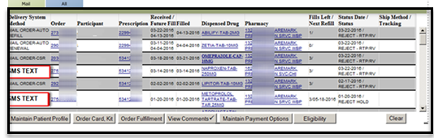

**PeopleSafe Order Status Screen:**

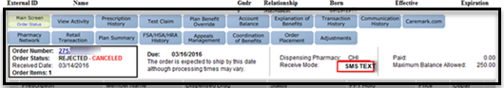

**Communication History Screen:**

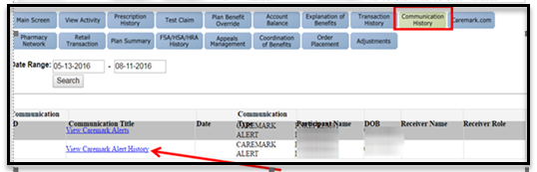

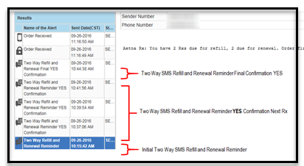

Top of the Document

|  |
| --- |
| Two Way SMS Refill Cell Phone Message Examples |

Icon - Important There is no additional cost to members for text messaging. However, if text messaging option is selected, standard text messaging rates will apply (as charged by the member’s cell phone company).

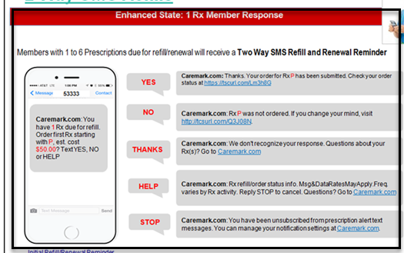

**Rx Member Response**

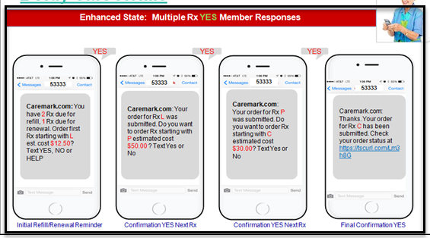

**Multiple Rx Yes Member Responses**

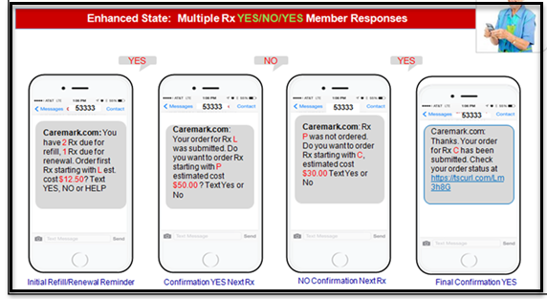

**Multiple Rx Yes/No/Yes Member Responses**

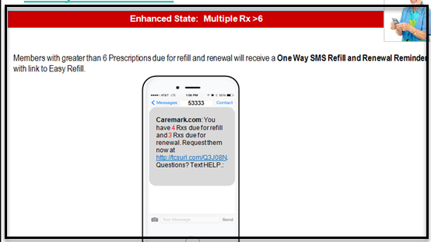

**Multiple Rx >6**

Top of the Document

|  |
| --- |
| Related Documents |

[Customer Care Abbreviations, Definitions, and Terms Index (017428)](https://thesource.cvshealth.com/nuxeo/thesource/#!/view?docid=c1f1028b-e42c-4b4f-a4cf-cc0b42c91606)

Top of the Document

Not To Be Reproduced Or Disclosed to Others Without Prior Written Approval

**ELECTRONIC DATA = OFFICIAL VERSION – PAPER COPY – INFORMATIONAL ONLY**